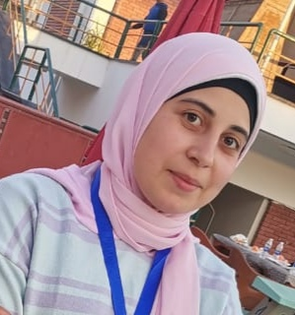

**Address:**

Nile Street, Majris vallige, Sedfa center , Assuit Governorate.

**Phone:**

01066051505

**Email:**

amlm@nursing. aun.edu.eg

Languages

* **Arabic**
* **English**

Skill Highlights

* **Problem solving.**
* **Time management**
* **Handling pressure.**
* **Adaptability.**
* **Good leader.**

Education

**Bachelor of Nursing**: Demonstrator in geriatric department.

Certifications

* Mechanical ventilator training (2017).
* First aids ( 2017).
* Elementary level course ( December 2020).
* IC3 GS5 Course (from September to October 2020).
* Publication of research in international journal( NOV2020).
* Crisis management (NOV2020).
* Quality standers in teaching (NOV2020).
* Summation of research paper to Assuit scientific journal( Sep2020).